32.30: a) 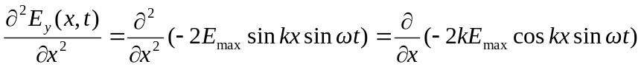
Similarly: 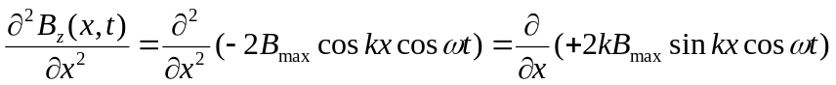
b) 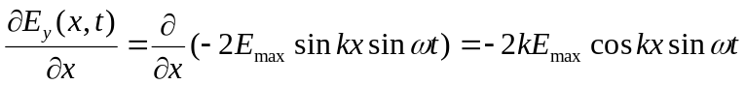 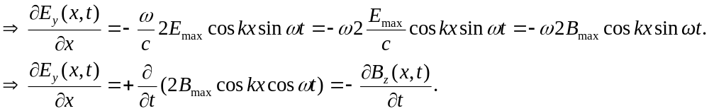
Similarly: 